Product Demo Checklist!

🧩 Product Demo Assessment
One down, two more to go! 🎯
The Product Demo is designed to assess your ability to navigate both BackOffice and the POS App confidently.
Please follow the instructions below to record and submit your demo:

1. POS App Recording
- Create a Google Meet room and join using your iPad.
- Share your iPad screen and walk through the checklist below.
- Keep your recording within 5 minutes.

2. BackOffice Recording
- Create a separate Google Meet link for your BackOffice demo.
- Ensure you’ve added some products beforehand to showcase during your presentation.
- Briefly navigate and explain key features.
- Keep this video within 5 minutes.

Once both recordings are complete, share the links with your coach for review and await feedback.
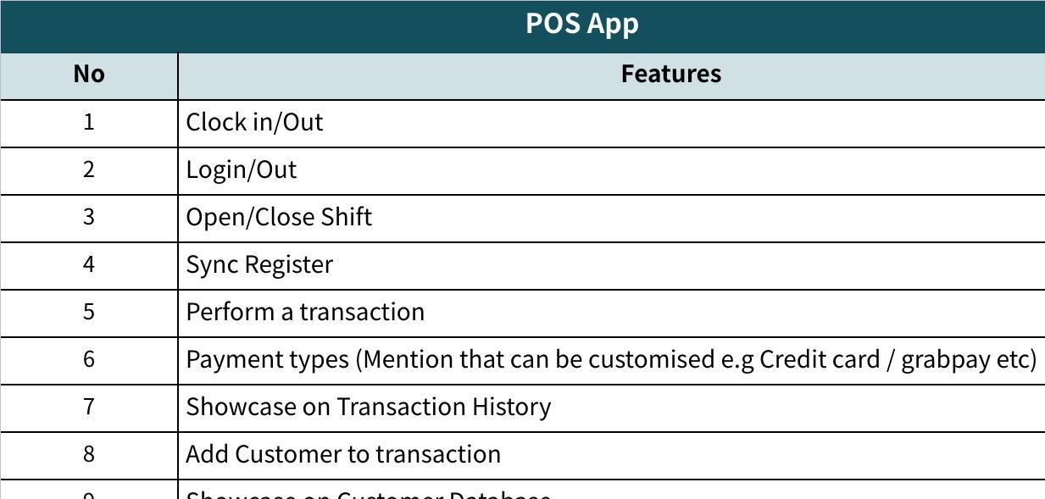
Click the image to view the sheet.

Here are some samples for you! :
POS App Demo
[POS register.mp4]

BackOffice Demo
[BackOffice Demo.mp4]

